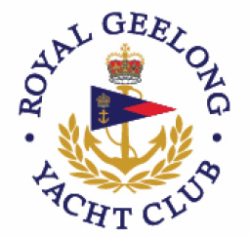
2018 GILL One Design Regatta
Incorporating the
Sydney38 Victorian Championships
VXone Victorian Championships

15th & 16th September 2018

Hosted by
Royal Geelong Yacht Club

ON-WATER EMERGENCY PLAN

On-Water Only
Abridged Version

Key Personnel
Name | Event Role | Responsibility | Phone
Phil Clohesy ** | RGYC General Manager | Media Management | 0438 787 263
John Kint | RGYC Commodore | Media Management | 0407 834 335
Mike Williams ** | RGYC Sailing Manager | On Shore Coordinator | 0437 689 928
Peter Kirman ** | RGYC Ops Manager | OH&S Coordinator | 0439 275 294
Max Stein** | Principle Race Officer | On Water Supervision | 0471 334 624
Mike Williams ** | RGYC Sailing Manager | Event Coordinator | 0437 689 928

** The Emergency Management Team (EMT) will comprise Phil Clohesy, Peter Kirman, Mike Williams and Max Stein
Media Management

In the event of an emergency situation, all media enquiries are to be directed to;

- 1st – RGYC General Manager, Phil Clohesy 0438 787 263
- 2nd - RGYC Commodore, John Kint 0407 834 335

Under no circumstances should any other person or organisation speak to the media during an emergency.

On-Water Incident Management

All on-water incidents will initially be communicated to the Radio Room using VHF Channel 16 or the VHF channel applicable to the particular race course. This communication will be from the vessel affected in terms of that vessels safety protocols. In most instances either the PRO or an Area Supervisor will be monitoring radio communication on that channel.

The initial action of the Radio Room will be to transfer the discussion to mobile phone with the vessel concerned to proceed with management of the incident (ie: take the call off public access radio). This will only take place if the vessel is in a good mobile phone reception area.

However if the situation is deemed severe or moderate, the first action will be to contact emergency services on 000, followed by the transferring the communication to mobile phone.

When appropriate, the PRO and EMT will be contacted to be advised of the situation. As the radio room is manned by two people during racing, this may occur concurrently with the above actions.

Incident and emergencies reported may include, but not limited to;

- Severe Incident – immediate action to call 000 then PRO

  - Man overboard (MOB) for greater than 10 minutes.
  - Potential loss of life.
  - Mayday call
  - Severe weather warning

- Moderate Incident – immediate call to 000 then PRO

  - Damage to vessel
  - Sinking vessel
  - MOB
  - Serious injury
  - Potential weather deterioration
  - Potential for incident to become a Severe incident

- Minor Incident – PRO & EMT to monitor situation and call 000 if required

- Crew injury
- Pan-Pan call

NB: All levels of incidents require an Incident Report to be completed.

On-Water Emergency Evacuation Locations

The Primary Evacuation Location for Ambulances or other emergency services to meet vessels with injured people is the Royal Geelong Yacht Club

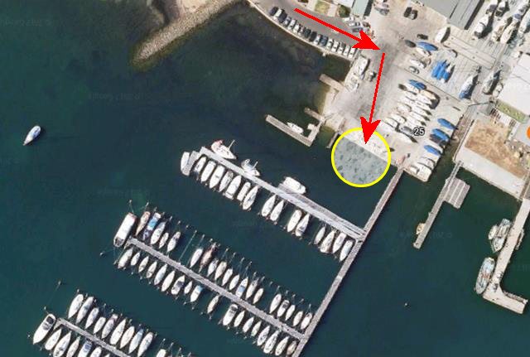
Ambulance Evacuation Point

Emergency Response Guidelines

Crew Injury or medical situation

First person on scene:

• Provide first aid [if safe to do so]
• Move injured person the neutral area if safe to do so
• Radio call to RGYC Radio Room to advise situation and request assistance if required.
State;
- Boat name
- Location
- Medical needs of crew
- Assistance needed for the injured crew member

On Shore Coordinator (As Area Supervisor):

• On Shore Coordinator to transfer conversation to mobile phone
• On Shore Coordinator to contact 000 if further assistance required
• On Shore Coordinator to contact PRO
• On Shore Coordinator to advise EMT of situation

Boat Skipper (As Area Supervisor):

• Proceed to emergency access point as directed by mobile phone
• Determine if other boats are in immediate area and contact if necessary.
• Effect what repairs are possible and / or clear equipment and fittings to enable access by rescue craft / persons.
• Keep rescuers informed about current situation
• Implement disaster plan level as appropriate

Event Coordinator:

• Ensure that PRO, Event Site Manager and Media Coordinator are aware of situation if required
• Coordinate support within marina
• Ensure Incident Report Form is completed

Man Overboard (MOB)

First person on scene:

• Ensure all other persons are on board are safe
• Commence emergency response rescue as per the yacht’s emergency rescue plan
• If MOB recovery is not imminent, radio RGYC Radio Room to advise situation and request assistance if required.
State;
- Boat name
- Location
• Issue personal safety equipment and have other equipment to hand
• Keep rescue crew informed about current situation

On Shore Coordinator (As Area Supervisor):

• On Shore Coordinator to transfer conversation to mobile phone
• On Shore Coordinator to contact 000 if further assistance required
• On Shore Coordinator to contact PRO
• On Shore Coordinator to advise Event Coordinator of situation

Boat Skipper (As Area Supervisor):

• Determine if other boats are in immediate area and contact if necessary.
• Keep rescuers informed about current situation
• Implement emergency rescue plan

Event Coordinator:

• Ensure that PRO, Event Site Manager and Media Coordinator are aware of situation if required
• Ensure Incident Report Form is completed

Yacht Capsize and or Sinking

First person on scene:

• Ensure all other persons are on board are safe and accounted for
• Attend to the immediate needs of any injured persons
• Determine the condition of the vessel
• Commence emergency response as per the yacht’s emergency rescue plan
• If recovery of situation is not imminent, radio RGYC Radio Room to advise situation and request assistance if required.
State;
- Boat name
- Location
- Medical condition of crew
• Issue personal safety equipment and have other equipment to hand
• Keep rescue crew informed about current situation

On Shore Coordinator (As Area Supervisor):

• On Shore Coordinator to transfer conversation to mobile phone
• On Shore Coordinator to contact 000 if further assistance required
• On Shore Coordinator to contact PRO
• On Shore Coordinator to advise Event Coordinator of situation

Boat Skipper (As Area Supervisor):

• Determine if other boats are in immediate area and contact if necessary.
• Keep rescuers informed about current situation
• Implement emergency rescue plan

Event Coordinator:

• Ensure that the PRO, Event Site Manager and Media Coordinator are aware of situation if required
• Ensure Incident Report Form is completed

Yacht Collision

First person on scene:

• Ensure all other persons are on board are safe and accounted for
• Attend to the immediate needs of any injured persons
• Determine the condition of the vessel
• Commence emergency response as per the yacht’s emergency rescue plan
• If recovery of situation is not imminent, radio RGYC Radio Room to advise situation and request assistance if required.
State;
- Boat name
- Location
- Medical condition of crew
• Issue personal safety equipment and have other equipment to hand
• Effect repairs if possible and or clear equipment and fittings to enable access by rescue craft/persons
• Keep rescue crew informed about current situation

Radio Room (As Area Supervisor):

• Radio Room to transfer conversation to mobile phone
• Radio Room to contact 000 if further assistance required
• Radio Room to contact PRO
• Radio Room to advise Event Coordinator of situation

Boat Skipper (As Area Supervisor):

• Determine if other boats are in immediate area and contact if necessary.
• Keep rescuers informed about current situation
• Implement emergency rescue plan

Event Coordinator:

• Ensure that PRO, Event Site Manager and Media Coordinator are aware of situation if required
• Ensure Incident Report Form is completed

